NovaTech Revenue Intelligence: Quick Chat Q&A Log
Each question is labeled BEFORE. Where an after-fix answer has also been captured, it is stacked directly underneath. New questions asked only in the after (Topic-fixed) state appear at the end.
Q: Which campaign channel drives the most revenue?
BEFORE
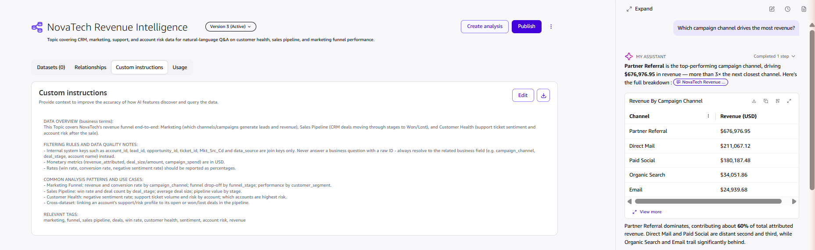
AFTER
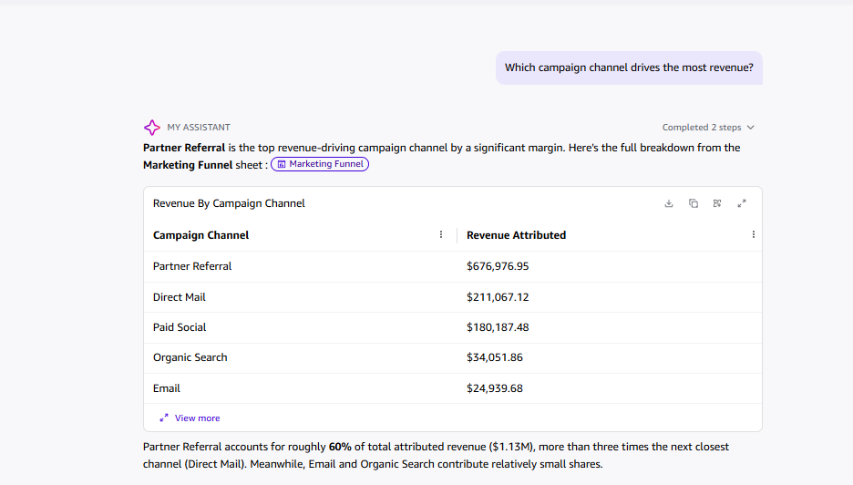
Q: Which campaign channel has the highest average response rate?
BEFORE
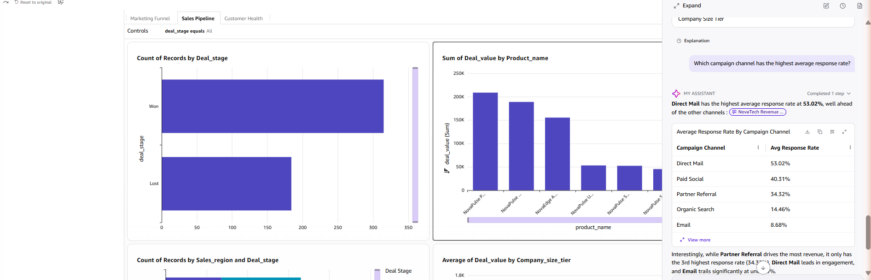
AFTER
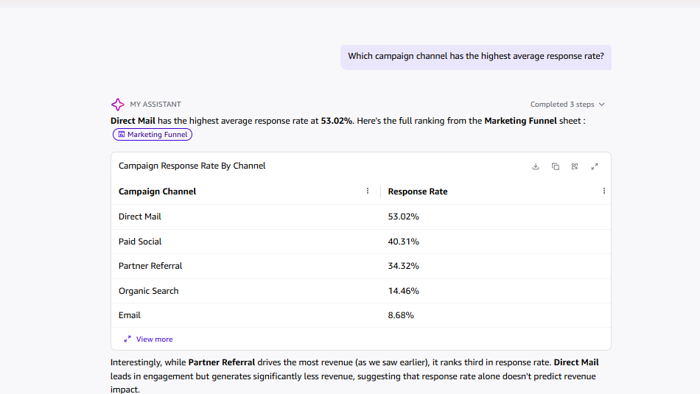
Q: What is the win rate in the Sales Pipeline sheet?
BEFORE
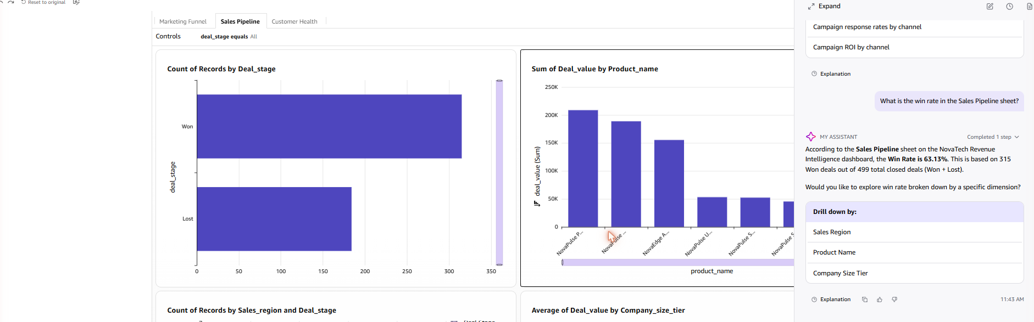
AFTER
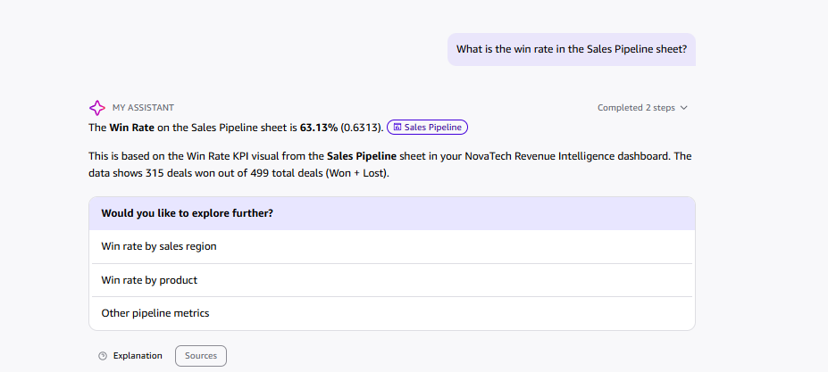
Q: What is the average deal size by company size tier?
BEFORE
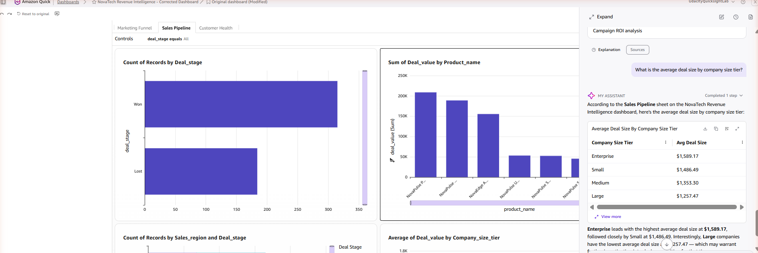
Q: Which product area receives the most support tickets, and what is the average resolution time for critical priority tickets?
BEFORE
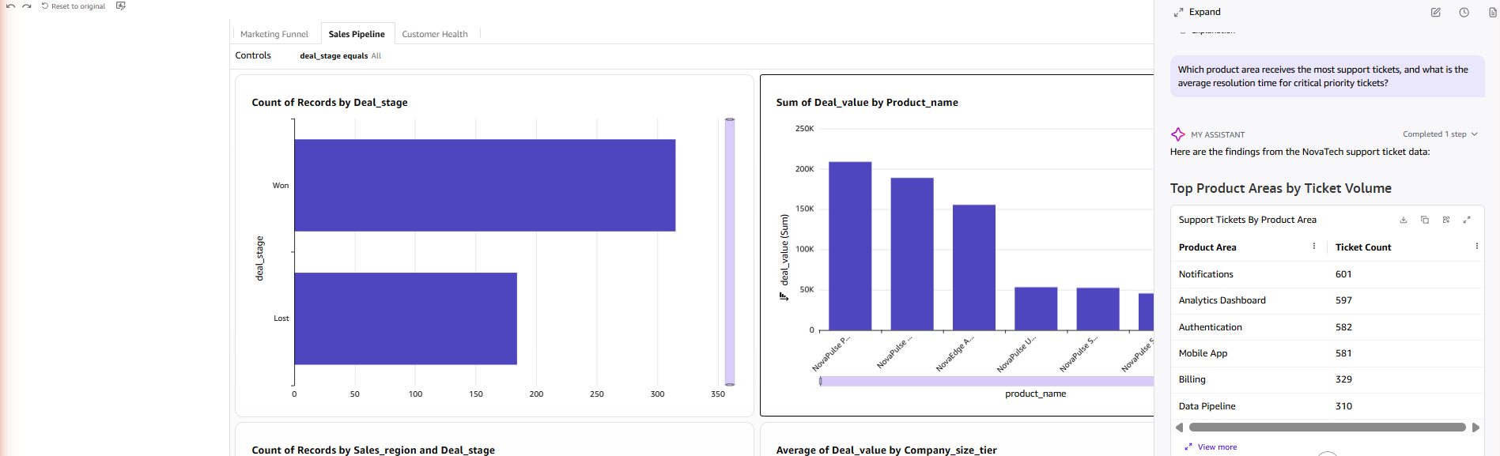
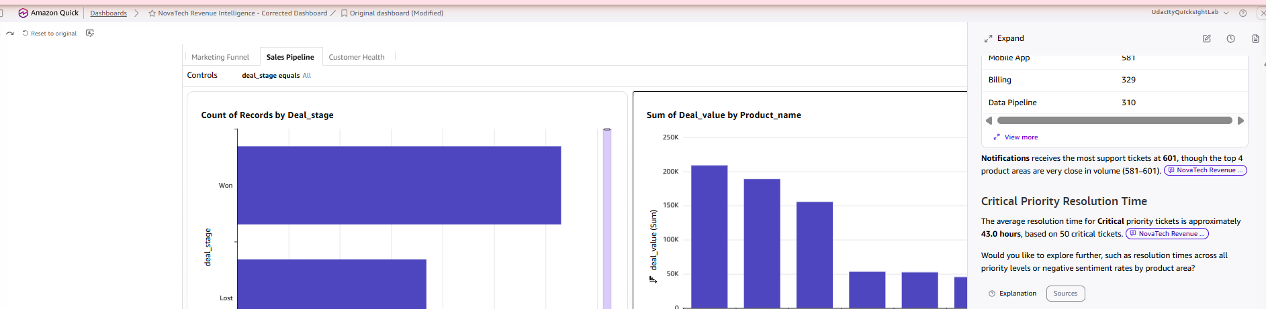
AFTER
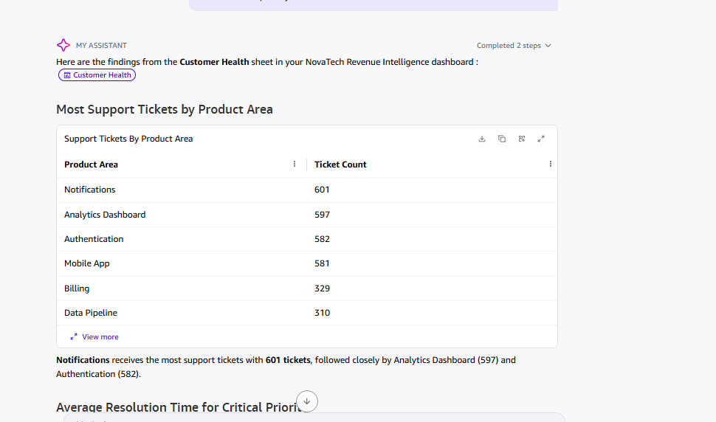
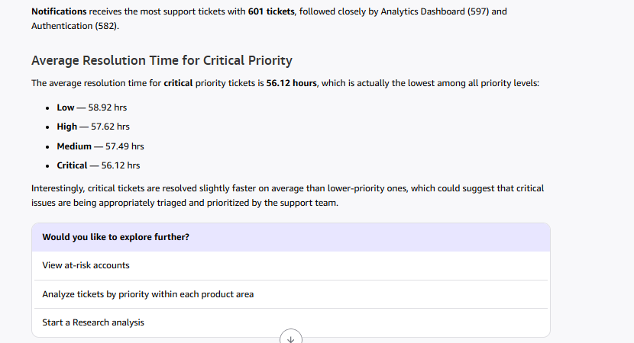
Note: the before answer reported 43.0 hrs average resolution for critical tickets (based on a 50-ticket subset); the after answer reports 56.12 hrs as part of a full priority breakdown, consistent with a separate "average resolution time" query (56.13 hrs). Minor inconsistency, likely due to different underlying filters/sample sizes used by Quick Chat between runs.
Q: Which accounts have both high support ticket volume and high total deal value at risk? (cross-dataset)
BEFORE
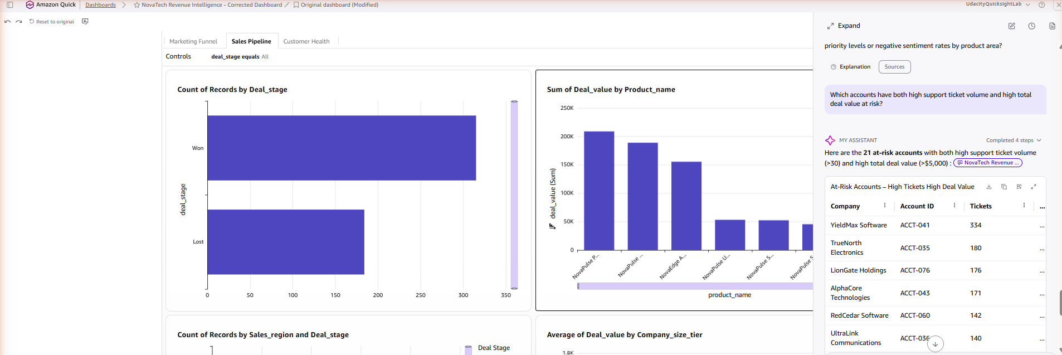
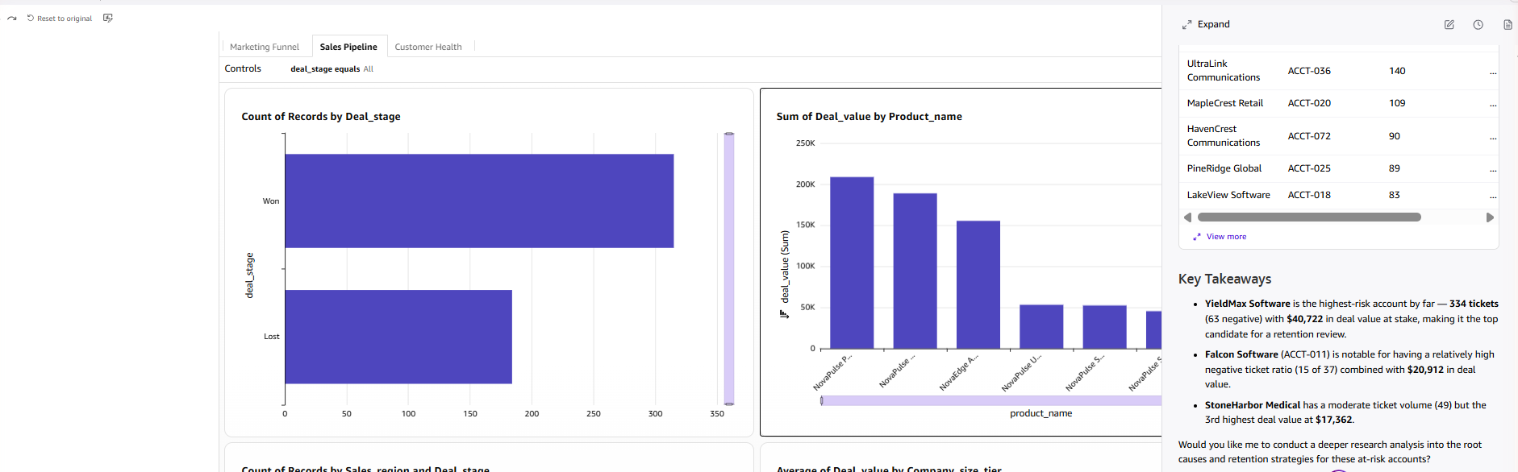
AFTER
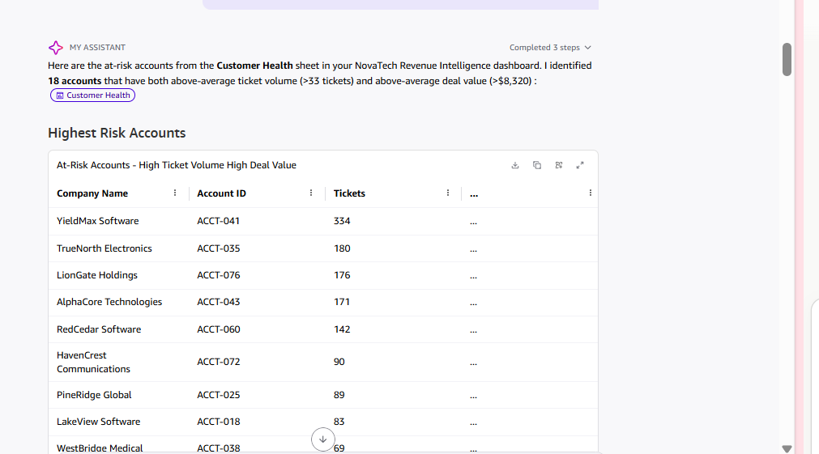
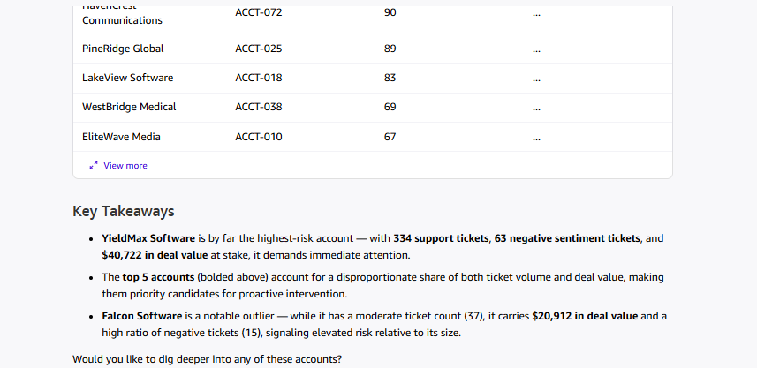
Q: Which campaign has the worst ROI, and what is the average campaign ROI overall?
BEFORE
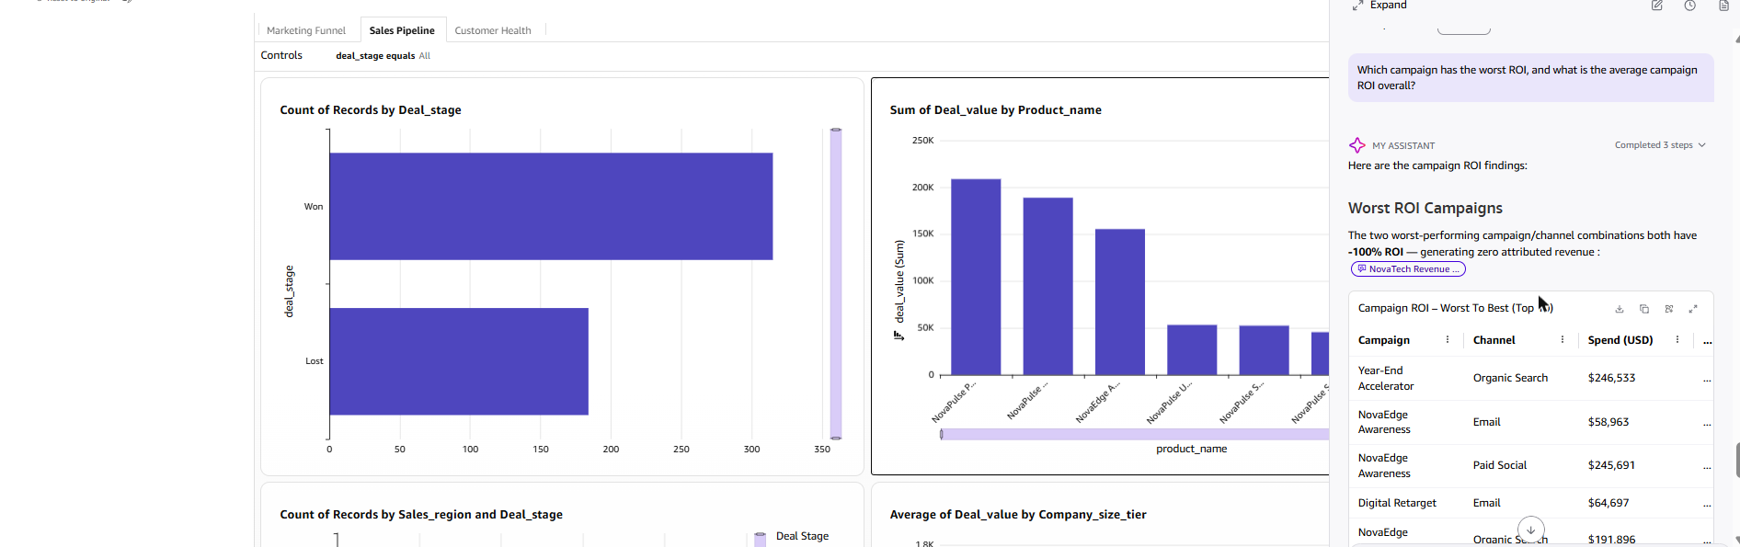
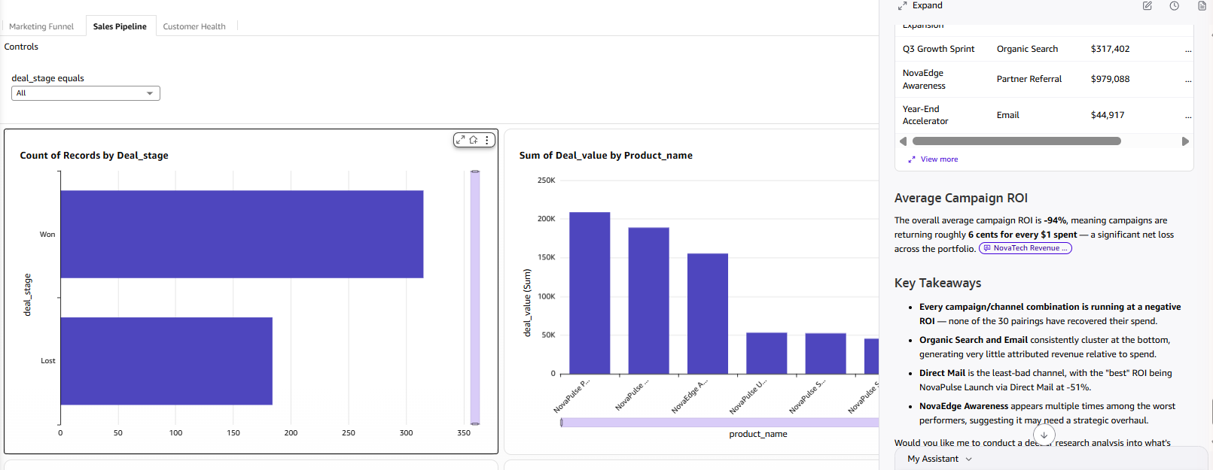
AFTER
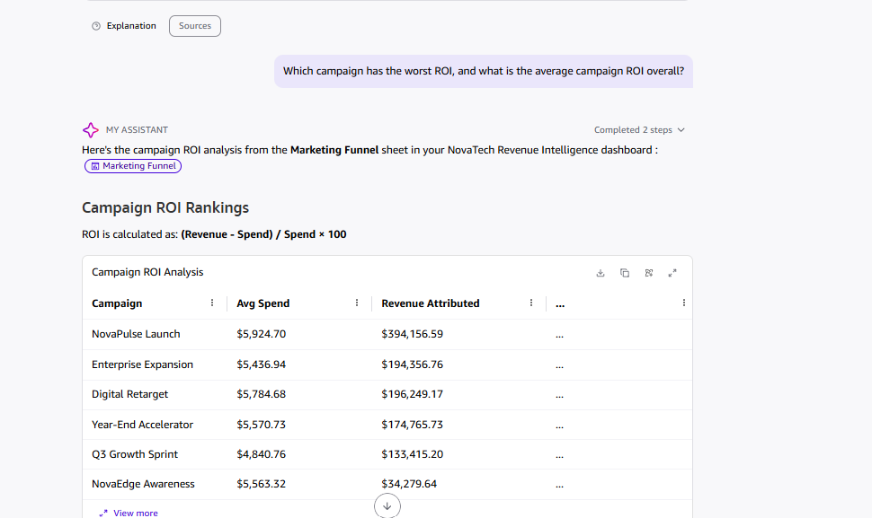
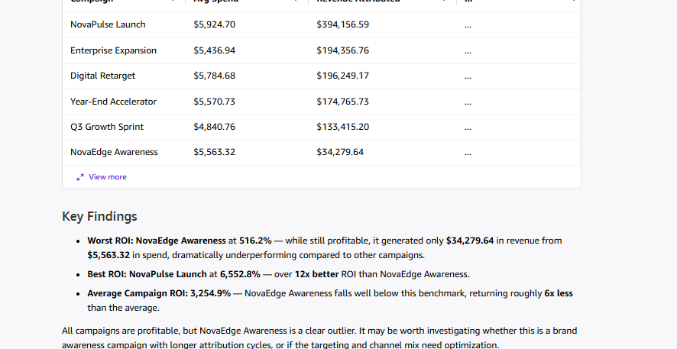
Note – verified root cause (after is correct): the before answer computed ROI per campaign–channel pairing by summing campaign_spend across all lead-level rows, yielding an inflated, all-negative result (average −94%). A follow-up query of the underlying Marketing Funnel dataset confirmed that campaign_spend is a campaign-level value that is duplicated ("fanned out") across every lead row of that campaign, so SUMing it multiplies the true spend by the number of leads. The dashboard's own spend visual is explicitly labeled “Avg Campaign Spend vs Total Revenue by Campaign – spend fan-out corrected,” meaning the AVERAGE recovers the true single per-campaign spend figure, while revenue_attributed is a genuine per-lead value that sums correctly across channels (channel sums for NovaPulse Launch total exactly $394,156.59, matching the campaign total). This confirms the after answer's methodology (average spend per campaign) is the correct one, giving an all-positive result (average +3,254.9%; worst NovaEdge Awareness at 516.2%, best NovaPulse Launch at 6,552.8%). The before answer's negative ROI figures were an artifact of double-counting spend and should be treated as incorrect, not as a real before/after change.
New Questions (After / Topic-Fixed State Only)
Q: What is the conversion rate by campaign channel?
AFTER
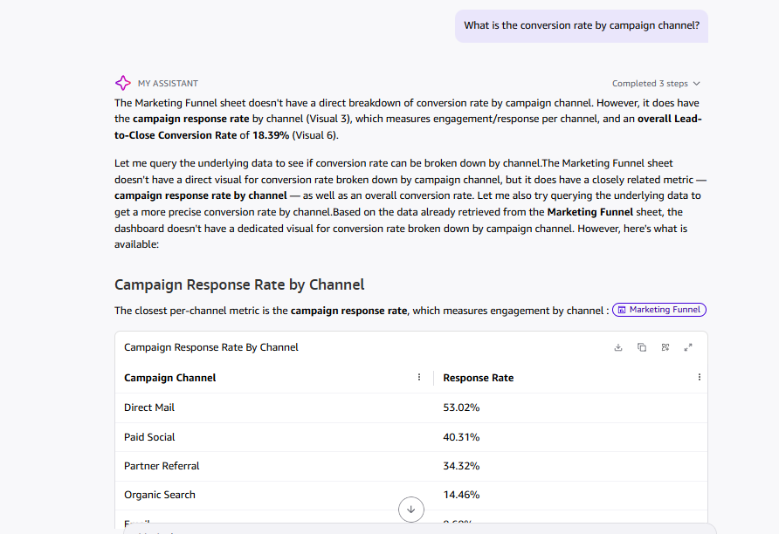
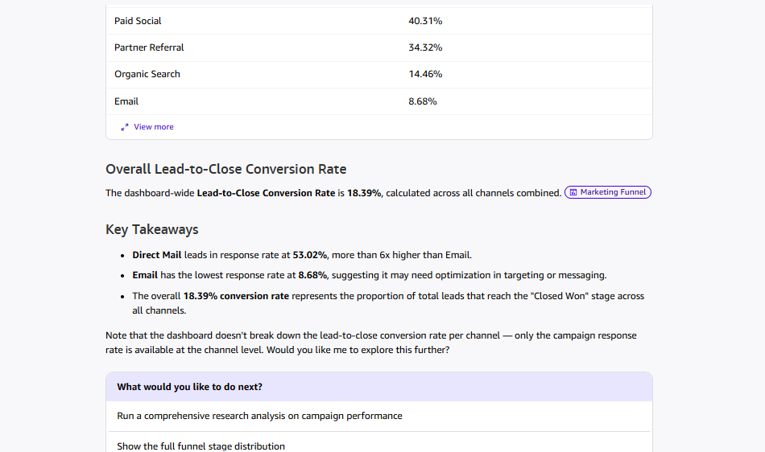
Q: What is the total pipeline value by deal stage?
AFTER
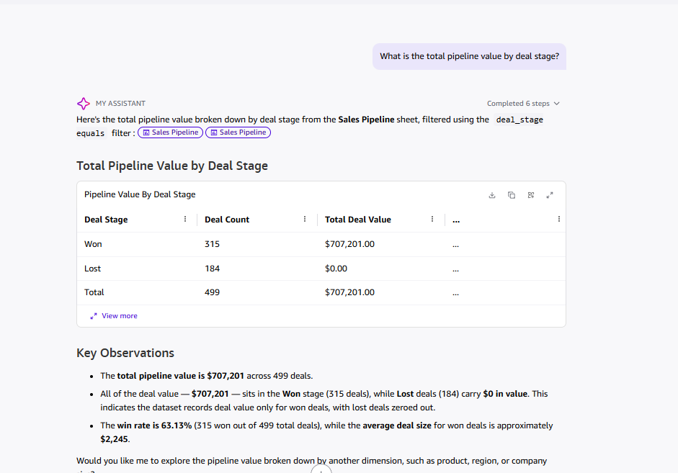
Q: What is the negative sentiment rate by account, and which accounts have the highest negative sentiment rate?
AFTER
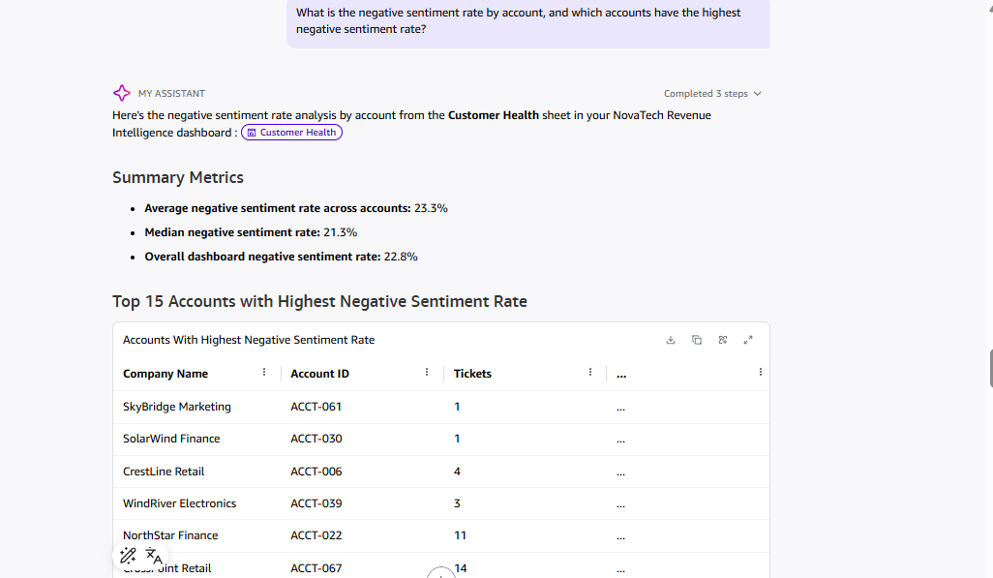
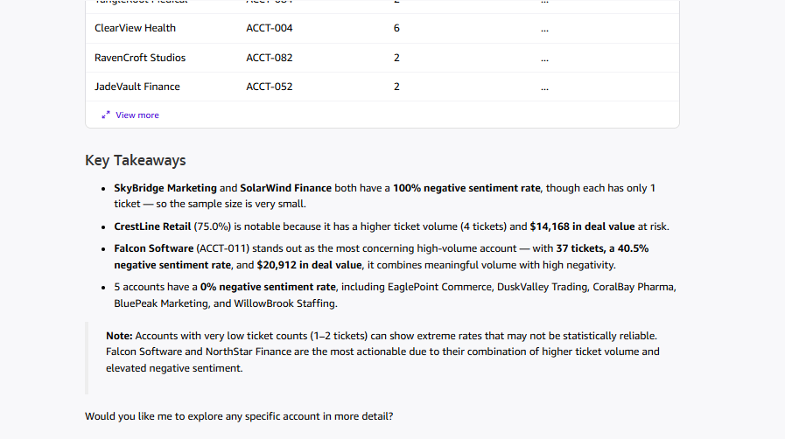
Q: How does an account's support ticket risk profile relate to whether their deal was Won or Lost? (cross-dataset)
AFTER
